
How much should I give?
As Christians, giving is both a sign of our love for God and a response to His abundant generosity. We are stewards of all that God has entrusted to us — our time, skills, money, and possessions — and we are called to use these gifts faithfully in His service, knowing we are accountable to Him.
‘Yours, Lord, is the greatness and the power and the glory and the majesty and the splendour, for everything in heaven and earth is yours.’ (1 Chronicles 29 v 11)
As part of the Diocese’s Centenary, we are called to offer generously of our time, talents, and money to the cause of Christ. Stewardship is not just about helping the church meet its needs; it is about giving back to God with gratitude and resourcing His Church for mission and growth.
God knows each of our circumstances, and giving should always be prayerful and joyful — never a legalistic obligation. The Bible reminds us that what matters most is not the size of the gift, but the spirit in which it is given. We are encouraged to give freely, generously, and in proportion to what we have.
‘For if the willingness is there, the gift is acceptable according to what one has, not according to what one does not have’ (2 Corinthians 8 v 12)
How do I know if I am giving generously?
- Is the amount I am giving away realistic in relation to my income?
- Can I see an element of sacrifice in my giving? Does it impact on my lifestyle?
- Is my giving a priority from what I receive each week or month, or just what is left over?
- If what I give away was given back to me, would I notice?

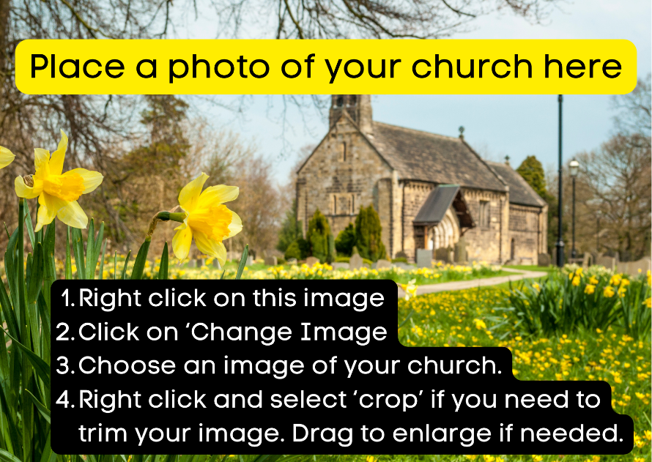
We are so grateful to God for the ways YOUR CHURCH NAME HERE has grown in recent years. Thank you for being a part of that growth and your commitments and contributions to church life.

Your Church Name Here
We couldn’t pursue our God-given vision without your generous gifts of time, talent, and finance. We invite all regular church members to contribute however they can.
Regular giving helps us plan our mission and ministry, while special appeals allow us to respond in times of need. To make giving simple and effective, we've joined the Parish Giving Scheme (PGS). Inside, you'll find ways to start giving through PGS and tips for reviewing your current giving.
Why are regular donations so important to our church?
The ministry of our church is sustained by church members who generously give their time and money to ensure that there is a Christian presence within our community. Regular donations help us to plan confidently for the future.

What is the Parish Giving Scheme?
As cash and cheque use declines, PGS offers a simple, secure way to give regularly via Direct Debit. It’s the Church of England’s system for managing donations, claiming Gift Aid, and easing admin for local churches — all under the protection of the Direct Debit Guarantee.

How does it work?
Gifts are collected on the 1st of the month (or quarterly/annually) and reach the church by the 10th. Gift Aid is passed on by the 25th, improving cash flow and efficiency.
First, review your giving – there is guidance over the page to help you do this.
There are then three ways to set up or change your gift:
- Online at www.parishgiving.org.uk (or scan the QR code below)
- By telephone 0333 002 1271 Monday to Friday between 9am and 5pm
- By post – just ask Ruth Wood (our Treasurer) or Lindsey Seddon (our PGS Parish representative) for a form
For any of these methods our PGS code [insert PGS CODE HERE] ensures that your gift goes to our church.
If you currently have a standing order, you will then need to cancel this yourself.

Why should I choose to increase my gift each year by inflation?
PGS offers an optional yearly increase in line with inflation, helping your gift retain its value. You’ll be notified in advance and can adjust or opt out anytime. PGS uses the latest Consumer Price Index (CPI) to calculate increases. For example, 3% CPI would raise a £100 gift to £103. Changes are always optional.

What are the main benefits of using PGS?
PGS provides our church with a regular, tax-efficient income that can grow with inflation — all with minimal admin. It’s a secure, confidential, and easy way for you to support our mission now and in the future.

[YOUR PARISH NAME] – Parish Giving Scheme
(edit hyperlink to your PGS giving page then delete this line)

PGS Code: [YOUR PGS CODE HERE]
Will our church be charged for this scheme?
No — the scheme is fully funded by the national church, so every penny you give goes directly to us.

Can I choose the day my gift is collected?
Unfortunately not — for consistency across all 35 participating dioceses, donations are collected on the 1st of each month.

I already give by standing order. Why would I change to PGS?
PGS simplifies admin, speeds up Gift Aid processing, and makes it easy to adjust your giving anytime. Taxpayer or not, anyone can use it — and you’ll have a clear record if giving online.
PGS Code 030603338

How can I start to give through PGS?

