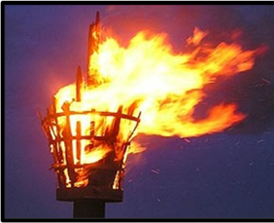

It was inspiring to hear stories of people who have set things up and learn some of the lessons.

I have enjoyed being able to talk in groups and meeting others from the diocese. I have been inspired by the other participants and the guest speakers to give it a go.

**The Beacon Course**

**The Beacon Course**

**Four evenings on zoom**

**Aim – to light the fires for New Local Congregations by:**

* **Inspirational input**: giving an example with plenty of time to feedback and draw out
* **Who to** ***not* how to**… so, at the end of four weeks, let’s try this with courage
* **All colours** – reaching across traditions, bringing out richness
* **Asset-based approach** – encouraging us to spot, ‘What is in your hand?’

Really inspiring stories shared by fantastic people.

**Beacon Course Dates:**

**Monday 19th September, Monday 26th September; Tuesday 4th October, Tuesday 11th October at 7.30pm–9 pm on zoom**

**To book, email:** [**beingwitnesses@blackburn.anglican.org**](mailto:beingwitnesses@blackburn.anglican.org)

**or telephone Joy Rushton: 07388 137265**

[**beingwitnesses@blackburn.anglican.org**](mailto:beingwitnesses@blackburn.anglican.org)

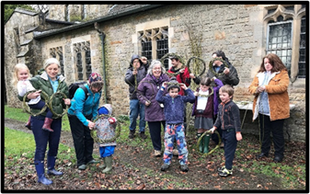

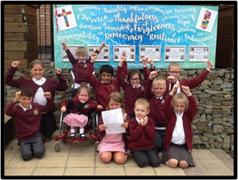**Course Leader: Bishop Jill Duff**

**Bishop of Lancaster**

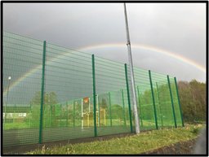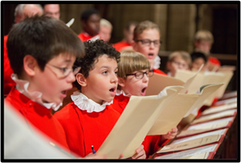

The ***Being Witnesses*** Vision 2026 theme has the following priorities:

* Sharing the gospel with confidence
* Enabling human flourishing through social action
* Planting 10 strategic church plants and 200 new local congregations
* Caring for God’s creation