**Dolphinholme Pilgrimage Walk**

Our Dolphinholme Pilgrimage Walk is a circular walk which takes you around two hours and is about 3 miles. The walk is fairly gentle, encompassing public footpaths and some road walking.

*Start your walk at St Mark’s church building, taking the right path from the main door.*

**Beginning your prayer walk -** Lord God of all Creation, we pray for our walk today. Give us eyes to see the beauty and value in all that you have made. Direct our thoughts and teach us to pray. Amen.

**Praying for a church building** - Lord God, we thank you for this place of worship. May it be a place of peace for the wearied, hope for those who are worried, joy for the sad, faith for those doubtful and a place where all are welcome. We thank you for all who care for this building and its grounds; may all we do there glorify you. Amen.

*Walk down the path and then down the steep concrete path into lower Dolphinholme. At the bottom take the road roughly straight ahead, crossing over the bridge.*

**Stopping by the allotments -** Stop and say a prayer for the allotments and for all who grow food, both as a hobby and a business. Can you recognise any of the plants being grown?

**Praying for the homes -** O God, whose Son was content to share the life of Nazareth, we pray for his peace and joy in every home. May we be good neighbours, thinking more of what unites us than what separates us. Give us the love to comfort the sorrowful and offer help to those in trouble, through your Son, our guide and pattern. Amen

*At the wooded area, take the footpath on the right, crossing the stile. Follow the edge of the field and cross at the gap in the fence into the next field. Cross this field to the left corner where you will find another stile. At the next field walk to the left side and exit the field through the footbridge through the hedge. Turn right to walk down the road*

**Praying for local businesses** – On your left you will see the track to Wyreside studio, a pottery business and, shortly down the road, on your right you will see Wyreside Hall, a hotel which is up for sale. Take some time to pray for local businesses and all that they bring to the community.

*Follow the road around as it bears right. At the end of the road turn right and continue on, after the bridge turn left and follow the footpath next to the Wyre.*

**Stopping to consider some flowers -** Read and consider this poem, from Christina Rossetti’s ‘Consider the Lilies of the Field’, it is based on Matthew 6:28-9

Flowers preach to us if we will hear.

The rose saith in the dewy morn:

I am the most fair;

Yet all my loveliness is born

Upon a thorn.

The lilies say: Behold how we

Preach without words of purity.

The violets whisper from the shade:

Men scent our fragrance on the air

Yet take no heed

Of humble lessons we would read.

The merest grass

Alongside the roadside where we pass

Tells of his love who sends the dew,

Who sends the rain and sunshine too.

**Stopping at a river -** Take a moment of quiet to reflect on the past week, perhaps on something you want to ask God’s forgiveness for. Pick up something small to throw into the river, like a small stone or a twig. As you throw your small object in, say sorry to God, who promises to forgive when we acknowledge and repent of our sins.

‘You will cast all our sins into the depths of the sea’ (Micah 7:19b)

*Eventually you will reach a gate, pass through it and then follow the road away from the lakes and towards the caravan park. Pass through the gates and immediately take the footpath to the right.*

**Stopping at the caravan site -** Lord Jesus, we thank you for holidays, for time with friends and family, time to relax and have fun. We pray for those who live and holiday here, that their time may be life-giving and that they may enjoy the beauty of their surroundings. Amen.

*Continue onwards and you will reach a field which you can walk straight across.*

**Stopping at a ponder point -** Take a moment to stop, maybe sit down and consider your surroundings. What can you see? What can you hear? What can you smell? What can you feel? Ask God to direct your focus towards one thing around you, like a particular plant or a certain view - how does it make you feel? Offer this to God in prayer.

*At the road take a left and then take the second right. Follow the road down to the farm and then pass through the black gate next to the farmhouse and into the sheep field.*

**Stopping by a farm**

We thank you, Good God, for the hard work which takes place here and in all the farms in our community, and ask your blessing on the families and on their enterprises. We thank you for the working animals and for the machines which take the toil out of our labour. Keep all food, equipment and materials in this place safe from pollution and theft, so that they may play their part in bringing in a harvest, to feed and clothe your world. Amen.

*Cross the field to the left corner and pass through the gate, following the path next to the stone wall onwards.*

**Stopping by some sheep -** This is a depiction of Jesus as the Good Shepherd. What stands out to you about it? Does seeing it near sheep affect its meaning? Turn these thoughts into prayers.

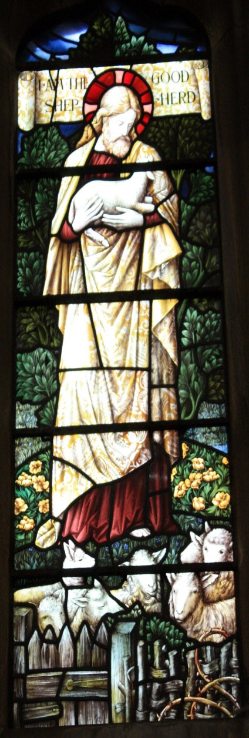



*Take the path on the left upwards through the wooded area. You will reach your final field, which you can walk through to return to where you started!*

**Ending your prayer walk** – Finish your prayer walk by offering up a prayer to God for what you have experienced on your walk today. You can finish with the Lord’s Prayer.

Our Father, who art in heaven,  
hallowed be thy name;  
thy kingdom come;  
thy will be done;  
on earth as it is in heaven.  
Give us this day our daily bread.  
And forgive us our trespasses,  
as we forgive those who trespass against us.  
And lead us not into temptation;  
but deliver us from evil.  
For thine is the kingdom,  
the power and the glory,  
for ever and ever. Amen.

*Follow this link to find an electronic version of the map -* https://www.plotaroute.com/route/274 7792?units=km

Some material here was taken and adapted from Seasonal Worship from the Countryside (SPCK, 2003).