**Over Wyresdale Pilgrimage Walk**

Our Over Wyresdale Pilgrimage Walk is a circular walk which takes around two hours and is about

3 miles long. The walk encompasses public footpaths and some road walking. We recommend wearing wellington boots as the ground can be quite muddy and we’re following an offline map (e.g. OS Maps, AllTrails) as exactly where the public footpaths are can be unclear.

*Start your walk at Christ Church church building, following the public footpath at the bottom of the church yard.*

**Beginning your prayer walk -** Lord God of all Creation, we pray for our walk today. Give us eyes to see the beauty and value in all you have made. Direct our thoughts and teach us to pray. Amen.

**Praying for a church building** - Lord God, we thank you for this place of worship. May it be a place of peace for the wearied, hope for those who are worried, joy for the sad, faith for those doubtful and a place where all are welcome. We thank you for all who care for this building and its grounds; may all we do there glorify you. Amen.

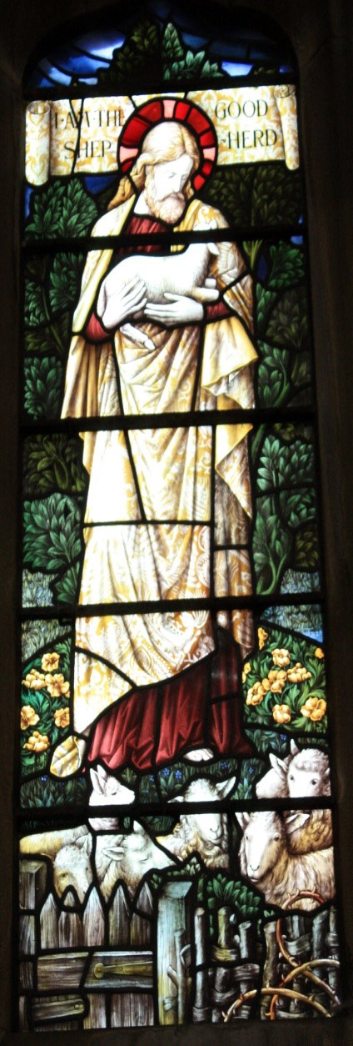**Stopping by some sheep -** This is a depiction of Jesus as the Good Shepherd. What stands out to you about it? Does seeing it near sheep affect its meaning? Turn these thoughts into prayers.

*Bear to the left, following the footpath, before*

*crossing over a stile and over a small wooden*

*bridge. Continue along the footpath and through*

*a gate and over another two stiles.*

**Praying for farms -** We thank you, Good God, for the hard work which takes place here and in all the farms in our community. We ask your blessing on the families and on all their enterprises. We thank you for the working animals and for the machines which take the toil out of our labour. Keep all food, equipment and materials in this place safe from pollution and theft, so that they may play their part in bringing in a harvest, to feed and clothe your world. Amen.

*Follow straight across from the farm, through the gate and then crossing the field to the stile. Follow the road to the right and along into Abbeystead village.*

**Praying for the primary school** – What do you think is important for primary schools? What challenges and opportunities do you think they face? Offer this up to God in prayer.

**Praying for homes -** O God, whose Son was content to share the life of Nazareth, we pray his peace and joy into every home. May we be good neighbours, thinking more of what unites us than what separates us. Give us the love to comfort the sorrowful and offer help to those in trouble, through your Son, our guide and pattern. Amen.

**Praying for the village hall** – What memories do you have of this village hall or other village halls and community spaces? Offer this up to God in prayer, praying for these centres of community life.

*Before the river follow the public footpath on the left and up the track.*

**Stopping by the river -** Take a moment of quiet to reflect on the past week, perhaps on something you want to ask God’s forgiveness for. Pick up something small to throw into the river, like a small stone or a twig. As you throw your small object in say sorry to God, who promises to forgive when we acknowledge and repent of our sins.

‘You will cast all our sins into the depths of the sea’ (Micah 7:19b)

**Praying for the livestock** – O Lord, who sends the rain and the sun so that the grass may grow, giving food for your animals; may you bless these fields and all within our community. Give us the love and wisdom to look after our animals as they look after us. Amen.

*Follow the track until it meets the road and then take a left, soon there will be a public footpath you can take on the left over a stile. Continue roughly straight ahead to follow the public footpath.*

**Stopping at a ponder point -** Take a moment to stop, maybe sit down and consider your surroundings. What can you see? What can you hear? What can you smell? What can you feel? Ask God to direct your focus towards one thing around you like a particular plant or a certain view, how does it make you feel? Offer this to God in prayer.

*When the footpath connects to the road take a right and walk on the road before taking the public footpath on the left. The footpath starts with a stile through a hedge. Follow the footpath straight ahead until you reach a farm and then continue, bearing right, through a metal gate which is another footpath. This footpath bears to the right and will eventually lead to a small settlement and Quaker burial ground.*

**Stopping at the burial ground** – You can stop here and pray. Thank God for the lives of the people buried here and for your own loved ones who have passed away. You could think of the role models in your own life who have trodden the path ahead of you. Give thanks for them.

*Follow the road and then take a left and follow the road down. At the T-junction take the left.*

**Stopping to consider some flowers -** Read and consider this poem, from Christina Rossetti’s ‘Consider the Lilies of the Field’, it is based on Matthew 6:28-9.

Flowers preach to us if we will hear.

The rose saith in the dewy morn:

I am the most fair;

Yet all my loveliness is born

Upon a thorn.

The lilies say: Behold how we

Preach without words of purity.

The violets whisper from the shade:

Men scent our fragrance on the air

Yet take no heed

Of humble lessons we would read.

The merest grass

Alongside the roadside where we pass

Tells of his love who sends the dew,

Who sends the rain and sunshine too.

*Soon you will reach Christ Church, well done on finishing your walk! The church building is always open with a small drinks stand at the back if you would like refreshments after your walk.*

**Ending your prayer walk** – Finish your prayer walk by offering up a prayer to God for what you have experienced on your walk today. You can finish with the Lord’s Prayer.

Our Father, who art in heaven,  
hallowed be thy name;  
thy kingdom come;  
thy will be done;  
on earth as it is in heaven.  
Give us this day our daily bread.  
And forgive us our trespasses,  
as we forgive those who trespass against us.  
And lead us not into temptation;  
but deliver us from evil.  
For thine is the kingdom,  
the power and the glory,  
for ever and ever.  
Amen.

*Follow this link to find an electronic version of the map -* https://www.plotaroute.com/route/275 0793?units=km

Some material here was taken and adapted from Seasonal Worship from the Countryside (SPCK, 2003).