Prepare your Heart
After Jesus was born in Bethlehem in Judea, during the time of King Herod, Magi from the east came to Jerusalem and asked, “Where is the one who has been born king of the Jews? We saw his star when it rose and have come to worship him.
Matthew 2:1-2

Prayer Activity Instructions
- As you go into this time of prayer, prepare your heart.

- We are called to lay down everything before Jesus in worship.

- Ask God if there is anything He is inviting you to give up to Him. Take a card crown and write down the things you need to lay down before God.

- Once you have written them down, place the crown at the foot of the throne and kneel before it. Spend some time worshipping His name.

The Sin Shredder
“Come now, let us settle the matter,” says the LORD. “Though your sins are like scarlet, they shall be as white as snow; though they are red as crimson, they shall be like wool.”
Isaiah 1:18

Prayer Activity Instructions
- No one is perfect and we all make mistakes.

- Do you need to ask for forgiveness?

- Take a post-it note and write or draw something that you need forgiveness for.

- When ready, take the post-it note, fold it in half and shred it. As you shred it imagine God shred every record of your sin through his mercy and love.

Fizzy Forgiveness
Get rid of all bitterness, rage and anger, brawling and slander, along with every form of malice. Be kind and compassionate to one another, forgiving each other, just as in Christ God forgave you.
Ephesians 4:31-32

Prayer Activity Instructions
- We all can carry pain from ways that people have hurt us.

- Do you need to forgive someone? Spend some time in quiet, asking
the Holy Spirit to show you.

- Pick up a tablet and think about surrendering to God the pain and resentment from a difficult situation.

- When you feel ready, drop the tablet into the water.

- Watch the tablet dissolve and imagine letting go of the grudge you have been holding.

Gratitude Cards
Therefore encourage one another and build up one another, just as you
also are doing.
1 Thessalonians 5:1

Prayer Activity Instructions
- Take a moment to still yourself.

- Ask God to bring to mind someone who would appreciate an encouragement card.

- Thank God for whoever comes to mind.

- Get creative and make or write them a card to encourage them.

- If they are a member of St Barnabas or St Paul’s Church you can post it into the post-box otherwise take it with you.
Thankfulness Line
Let everything that has breath praise the Lord. Praise the Lord.
Psalm 150

Prayer Activity Instructions
- Take a moment in silence with God.

- What are you thankful to Him for? You could use your senses: what can you see, feel, touch, smell, or hear that reminds you of the goodness of God? You could also look through the Psalms and find lines of praise to write down.

- Begin writing down your responses on your paper – feel free to get creative and draw, too.

- Peg your paper onto the line.

A Place at the Table
Then he said to his servants, ‘The wedding banquet is ready, but those I invited did not deserve to come. So go to the street corners and invite to the banquet anyone you find.’ So, the servants went out into the streets and gathered all the people they could find, the bad as well as the good, and the wedding hall was filled with guests.
Matthew 22:8-10

Prayer Activity Instructions
- Take a moment to take a seat at the table.

- Reflect on the bread and ‘wine’ in front of you. Jesus’ body and blood, broken and shed for you. What do you feel as you think of this? (If dietary requirements allow feel free to have some bread and ‘wine’.)

- When you are ready, stand, and walk around the table.

- Look at the cards on the table and pray for the oppressed, the marginalised, the lonely and the poor in heart. Pray they would know they have a place at the table. There are many more people who may feel they are marginalised which aren’t on the cards, if they come to mind pray for them too.

Be Still
Be still and know that I am God
Psalm 46:10

Prayer Activity Instructions
The Bible tells us to encourage one another, to build up the Body of Christ.

- This space is a space for you to rest with God.

- If you find being still challenging, set a timer on your phone for 10 minutes so you’re not watching the clock.

- Sit comfortably and notice your breathing; breathe deeply.

- Welcome the Holy Spirit.

- From your head to your feet, notice how your body feels; relax any tense muscles.

- Random thoughts filling your head? Don’t feel discouraged – keep handing them to God.

- Try using a breath prayer to help you focus – a short phrase or bible verse that focuses your attention on God (e.g. ‘I love You Father’ or ‘Speak Lord, your servant is listening’)

- Be attentive to what God might be saying – does a word, picture, bible verse or something else come to mind?

- After 10 minutes, thank God for spending this time with You.

Refiners Fire
In this you rejoice, though now for a little while, if necessary, you have been grieved by various trials, so that the tested genuineness of your faith—more precious than gold that perishes though it is tested by fire—may be found to result in praise and glory and honour at the revelation of Jesus Christ. Though you have not seen him,
you love him. Though you do not now see him, you believe in him and rejoice with joy that is inexpressible and filled with glory, obtaining the and filled with glory, obtaining the outcome of your faith, the salvation of your souls.
1 Peter 1: 6-9

Prayer Activity Instructions
- Look at the stones at various places around the fire. Which stone represents your heart today? How close does it feel to the fire of God’s passion and presence?

- As you identify a stone, what would it look like for your heart to move closer to the fire? Spend some time in conversation with God.

- Place your stone in the ‘fire’, surrendering to the work of the Refiner.

- As you pray, take out a gem from the fire in place of the stone. We are refined in the fire. Where in your life is God refining you at the moment?

- Take the gem with you to remind you of the work God is doing within and around you. He is making all things beautiful.

A Ripple Effect
Your kingdom come, Your will be done, on earth as it is in heaven...
Matthew 6:10

Prayer Activity Instructions
- Take a stone and think of it as the power of your prayer.

- Drop it into the water and watch the ripple effect.

- As you call for God’s Kingdom to come, what could the ripple effect across the nation(s) look like?

Be Bold
On the day the Lord gave the Israelites victory over the Amorites, Joshua prayed to the Lord in front of all the people of Israel. He said, “Let the sun stand still over Gibeon, and the moon over the valley of Aijalon.”
So the sun stood still and the moon stayed in place until the nation of Israel had defeated its enemies. Is this event not recorded in The Book of Jashar? The sun stayed in the middle of the sky, and it did not set as on a normal day.
Joshua 10:12-13

Prayer Activity Instructions
Throughout the Bible we see evidence of the people of God praying bold prayers, to bring about change in their lives and the lives of those around them for the glory of God. What “Sun Stand Still” bold prayer can we pray to God and have faith for Him to answer?

- Make a list of five big, bold prayers you can pray to God. Maybe it’s for your friend to become a Christian, maybe someone needs healing, maybe you need a job - where do you need a significant breakthrough?

- Pray over your list.

- Put the list in an envelope.

- Write the date on it one year ahead. So, if today is 19th April 2024, then write on the envelope “Open on 19th April 2025.”

- Put it somewhere safe at home, and open it in a year’s time. Tick off what God has done. Maybe put the envelope in your Bible and set a reminder on your phone or in your calendar to do this.

Pour Out your Heart
“And afterward, I will pour out my Spirit on all people. Your sons and daughters
will prophesy, your old men will dream dreams, your young men will see visions.
Joel 2:28

Prayer Activity Instructions
While in this place much might be placed on your heart from God. This is a place to take what God has told you and put it to paper to encourage yourself and others.

- Pick up a paintbrush and ask God what he wants to tell you.

- Paint whatever images come to mind. Don’t worry about whether the picture looks good, only think about whether it tells the message God has given you.

- When you’re done thank and praise God for giving you this message. If comfortable, after leaving this place, tell someone about your message.

Undignified Worship
And David danced before the Lord with all his might, wearing a priestly garment. - “I was dancing before the Lord, who chose me above your father and all his family! He appointed me as the leader of Israel, the people of the Lord, so I celebrate before the Lord. Yes, and I am willing to look even more foolish than this, even to be humiliated in my own eyes!
2 Samuel 6:14, 21b-22a

Prayer Activity Instructions
God doesn’t care how we worship him but about our hearts behind the praise. In our worship of him, he calls us to be all in, to be wholehearted in what we are doing before him; whether it be dancing, singing, reflecting, whispering, praying, kneeling, bowing, asking etc.



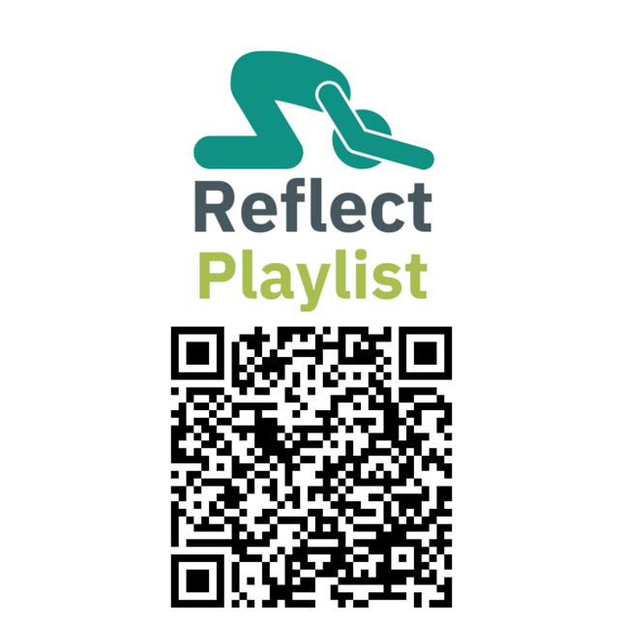
- Worship God in whatever way feels comfortable. If you have a phone, you can scan one of our QR Codes for a themed playlist.
Reflect Playlist
A more solemn playlist themed around reflecting on God and our relationship with him.

A good question to ponder when listening to this is:

What’s holding you back from knowing God better?
Praise Playlist
A joyful playlist themed around lifting praise to God, giving him all the glory.

A good question to ponder when listening to this is:

What are you thankful to God for?
Ask Playlist
A mixed playlist in tone, themed around asking God to help us live and act as he calls us to.

A good question to ponder when listening to this is:

What is God calling me to do?

Cast your Cares
Humble yourselves, therefore, under God’s mighty hand, that he may lift you up in due time. Cast all your anxiety on him because he cares for you.
1 Peter 5: 6-7

Prayer Activity Instructions
When praying, we can often bring our fears with us. This fear can often make us feel blind to God, which can then become baggage that we bring with us. We hold on to this baggage for many reasons such as our own pride, or perhaps if we don’t know how to let it go, or because we may not know we have it at all.

- During this time of prayer, cast your cares on Christ.

- Christ beat everything at the cross, including our fears and anxiety in our lives.

- Pause for a moment and ask God if there is a fear that is holding you back from embracing Him. Pick up a card and write or draw this fear.

- Roll up the card and place it in one of the holes in the cross and imagine this fear being overwhelmed by Christ’s immense sacrifice and care for you. Spend some time thinking and reflecting on how you’ve got a Saviour who in your fear lifts you up into his caring and loving arms.

See the Wonders of His Works
In the beginning God created the heavens and the earth - God saw all that he had made, and it was very good.
Gensis 1, 31a

Prayer Activity Instructions
- Look or go outside for a moment. What can you see, hear, smell and feel?

- God made it all, he gave the world colour, sound, smell and texture. Take a colouring sheet and give it some colour; as you do so, praise God for filling our world full of wonderful goodness.

Look to the Fields
When Jesus saw the crowds, he had compassion on them, because they were harassed and helpless, like sheep without a shepherd. Then he said to his disciples, “The harvest is plentiful but the workers are few. Ask the Lord of the harvest, therefore, to send out workers into his harvest field.”
Matthew 9.36-38

Prayer Activity Instructions
- Still your heart before the Lord

- Look: at the map of our parish. Where is your eye drawn to?

- Pray: for that part of our parish. Ask God to send workers into the harvest.

- Consider: how might God be calling you into the harvest field?

