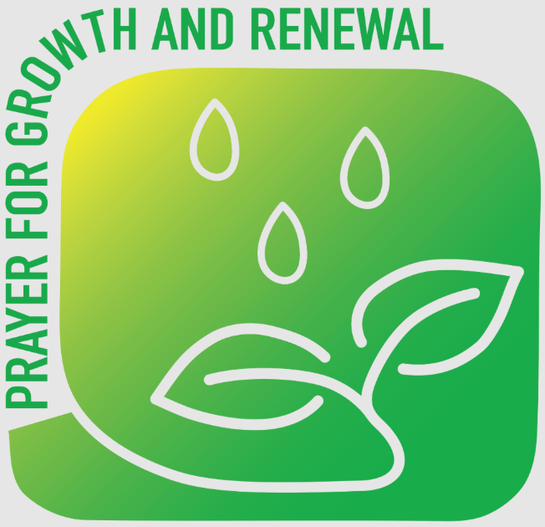

A short time of prayer for growth

Welcome

Our Diocesan Mission Prayer

God of Mission:
Who alone brings growth
to your church,
Send your Holy Spirit to give
Vision to our planning,
Wisdom to our actions,
Joy to our worship
And power to our witness.
Help our church to grow in numbers,
in spiritual commitment to you,
And in service to our local community,
Through Jesus Christ our Lord.
Amen

Today’s reading and/or image

A time of prayer (these prayers may be read)

Almighty God,
who called your Church to witness
that you were in Christ reconciling the world to yourself:
help us to proclaim the good news of your love,
that all who hear it may be drawn to you;
through him who was lifted up on the cross,
and reigns with you
in the unity of the Holy Spirit,
one God, now and for ever.
Amen

Heavenly Father,
pour on us your Holy Spirit to inspire us so that we might truly believe in and live the Good News. Grant us the confidence to proclaim the Good News to others and witness to the Gospel in our everyday life through our words and actions.
Amen

Lord,
We pray for our services, that in them everyone who comes will encounter you in all that is said and done. Guide us to plan, worship, act and witness as you would guide us, always being attentive to your prompting and your will.
Amen

Father,
We pray for our new 4pm service. We ask that you will be preparing the hearts of those who you want to come. Give us all the courage to invite people, to join in and step outside our comfort zone in your name. Always looking to share your love in Little Thornton and beyond.
Amen

Lord,
Help us to know you and to love you,
Alleviate our fears and fan the embers of trust within us,
Give us the courage to say yes to your invitation and help us to continue our journey with you.
Remind us Lord that you are the way the truth and the life and without you there is no life,
but with you and you alone there is fulness of life- life everlasting.
Amen

Finishing with everyone saying The Lord’s Prayer or The Grace

Our Father in heaven,
hallowed be your name,
your kingdom come,
your will be done,
on earth as in heaven.
Give us today our daily bread.
Forgive us our sins
as we forgive those who sin against us.
Lead us not into temptation
but deliver us from evil.
For the kingdom, the power,
and the glory are yours
now and for ever.
Amen.

May the grace of our Lord Jesus Christ,
the love of God,
and the fellowship of the Holy Spirit be with us all,
now and for evermore.
Amen.

